Basic Working Principal -

Stores the data as magnetic patterns.

2 Basic Types :

1) LoCo ( low-coercivity at 300 Oe )

2) HiCo ( high-coercivity at 4000 Oe )

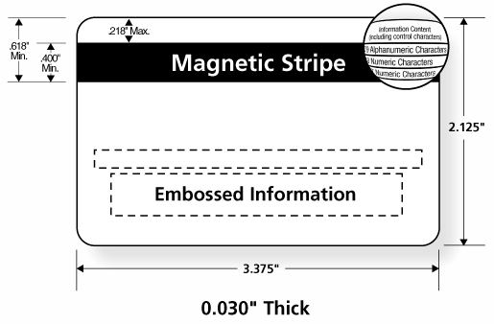

The [Payment Card Industry Data Security Standard](https://en.wikipedia.org/wiki/Payment_Card_Industry_Data_Security_Standard) (PCI DSS) is the security standard issued by the [Payment Card Industry Security Standards Council](https://en.wikipedia.org/wiki/Payment_Card_Industry_Security_Standards_Council) (PCI SSC). This data security standard is used by acquiring banks to impose cardholder data security measures upon their merchants.

Standards Used -

|  |  |  |
| --- | --- | --- |
| ISO | 7810 | Identification Cards - Physical Characteristics |
| ISO | 7811-1 | Embossing |
| ISO | 7811-2 | Magnetic stripe - low coercivity |
| ISO | 7811-3 | Location of embossed characters on ID-1 cards |
| ISO | 7811-6 | Magnetic stripe - high coercivity |
| ISO | 7813 | Financial transaction cards |

# **ISO/IEC 7813**

* Embossed characters by reference to [ISO/IEC 7811](https://en.wikipedia.org/wiki/ISO/IEC_7811)
* Embossing of expiration date the format (MM/YY or MM-YY)
* [Magnetic stripe](https://en.wikipedia.org/wiki/Magnetic_stripe) by reference to [ISO/IEC 7811](https://en.wikipedia.org/wiki/ISO/IEC_7811)
* [Integrated circuit](https://en.wikipedia.org/wiki/Integrated_circuit) with contacts by reference to [ISO/IEC 7816](https://en.wikipedia.org/wiki/ISO/IEC_7816)-1
* Integrated circuit without contacts by reference to [ISO/IEC 10536](https://en.wikipedia.org/w/index.php?title=ISO/IEC_10536&action=edit&redlink=1)-1, [ISO/IEC 14443](https://en.wikipedia.org/wiki/ISO/IEC_14443)-1, and [ISO/IEC 15693](https://en.wikipedia.org/wiki/ISO/IEC_15693)-1

## *Magnetic tracks stanadard data stream* **-**

## 

### **Track 1**

The Track 1 structure is specified as:

* STX: Start sentinel "%"
* FC: Format code "B" (The format described here. Format "A" is reserved for proprietary use.)
* PAN: Primary Account Number, up to 19 digits
* FS: Separator "^"
* NM: Name, 2 to 26 characters (including separators, where appropriate, between surname, first name etc.)
* FS: Separator "^"
* ED: Expiration data, 4 digits or "^"
* SC: Service code, 3 digits or "^"
* DD: Discretionary data, balance of characters
* ETX: End sentinel "?"
* LRC: [Longitudinal redundancy check](https://en.wikipedia.org/wiki/Longitudinal_redundancy_check), calculated according to [ISO/IEC 7811](https://en.wikipedia.org/wiki/ISO/IEC_7811)-2

The maximum record length is 79 alphanumeric characters.

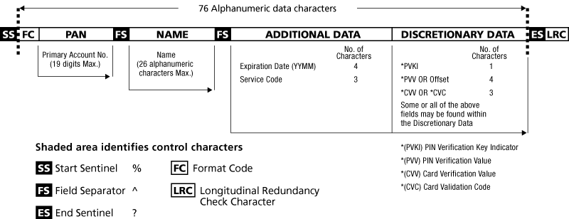

#### *Examples*

%B4815881002861896^YATES/EUGENE JOHN         ^37829821000123456789?

%B4815881002861896^YATES/EUGENE L            ^^^0000000      00998000000?

### **Track 2**

The Track 2 structure is specified as:

* STX: Start sentinel ";"
* PAN: Primary Account Number, up to 19 digits, as defined in [ISO/IEC 7812](https://en.wikipedia.org/wiki/ISO/IEC_7812)-1
* FS: Separator "="
* ED: Expiration date, YYMM or "=" if not present
* SC: Service code, 3 digits or "=" if not present
* DD: Discretionary data, balance of available digits
* ETX: End sentinel "?"
* LRC: [Longitudinal redundancy check](https://en.wikipedia.org/wiki/Longitudinal_redundancy_check), calculated according to ISO/IEC 7811-2

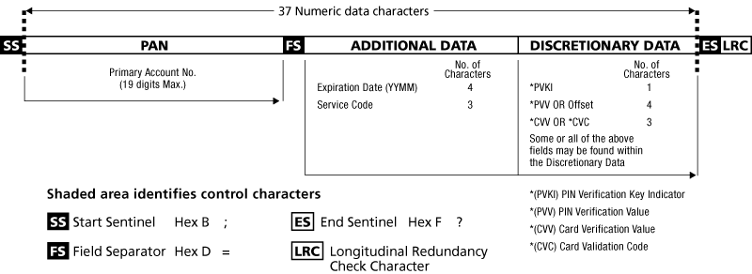

The maximum record length is 40 numeric digits (*e.g.,* 5095700000000).

### **Track 3 ( ISO 4909 )**

Track 3 is virtually unused by the major worldwide networks and often isn't even physically present on the card by virtue of a narrower magnetic stripe.

A notable exception to this is Germany, where Track 3 content was used nationally as the primary source of authorization and clearing information for debit card processing prior to the adoption of the "SECCOS" ICC standards. Track 3 is standardized nationally to contain both the cardholder's bank account number and branch sort code (BLZ).

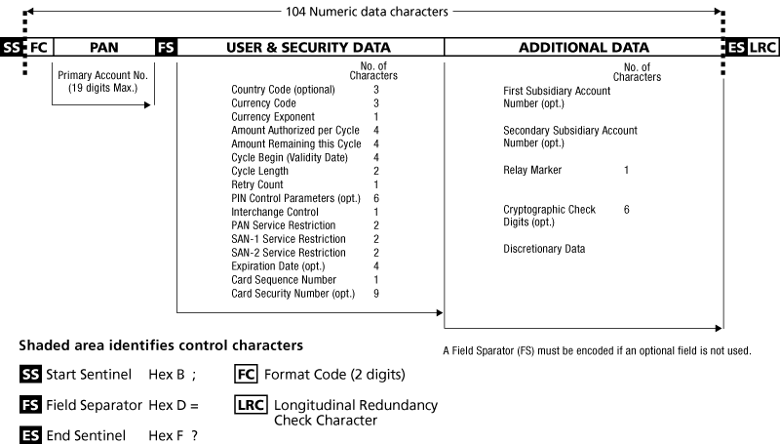

*Service code values common in financial cards:*

**First digit**

1: International interchange OK

2: International interchange, use [IC (chip)](https://en.wikipedia.org/wiki/EMV) where feasible

5: National interchange only except under bilateral agreement

6: National interchange only except under bilateral agreement, use IC (chip) where feasible

7: No interchange except under bilateral agreement (closed loop)

9: Test

**Second digit**

0: Normal

2: Contact issuer via online means

4: Contact issuer via online means except under bilateral agreement

**Third digit**

0: No restrictions, PIN required

1: No restrictions

2: Goods and services only (no cash)

3: ATM only, PIN required

4: Cash only

5: Goods and services only (no cash), PIN required

6: No restrictions, use PIN where feasible

7: Goods and services only (no cash), use PIN where feasible

analysis Hardware Tools -

**MagStripe Readers or Reader/Writer –** to read and write the data present on the Magnetic Stripe on the card.

# DEFTUN USB 3-Track Magnetic Stripe Magstripe Scanner Swipe POS Credit Card Reader (MSR90)

[Link to Buy](https://www.amazon.in/Deftun-3-Track-Magnetic-Magstripe-Scanner/dp/B01DVWQ2BO?tag=googinhydr18418-21&tag=googinkenshoo-21&ascsubtag=a8e1194f-b52f-4894-8569-daf7a4460cc6)

Price Around (2,178 INR)

Usb interface, keyboard emulation

* Work on windows and mac, and with txt, word, excel, pos systems or any keyboard type
* Reads 3 track data, high and low coercivity magnetic stripe cards
* Reads iso7811, aamva and most other card data formats
* Perfect for POS, Banking, Loyalty, Access Control and other applications